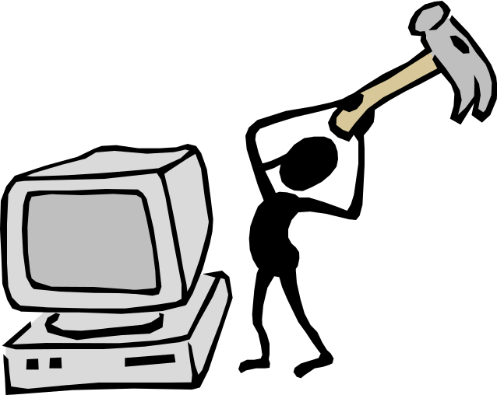Program 2A
(getting to know Java)

You will practice modifying a program by adding lines, deleting lines, and changing lines.
You will open the file Data2a.cpp from the Student Master diskette, make corrections, and then save the corrected program on your own diskette. The program will look like the following:

//Prog 2A
//Practice problem to learn how to use the editor and compile and run a program

public static void main(String [] args)
{
System.out.println( “The program you”); The program you
System.out.println( “ are using is ”); are using is
System.out.println( “called Pascal. It”); called Pascal. It
System.out.println( “ will soon be your friend.)”; will soon be your friend.
System.out.println( “Opps!! A mistake was)”; Opps!! A mistake was
System.out.println( “just made. Please)”; just made. Please
System.out.println( “correct me.”); correct me.
}

Compile and Run the program by pressing <Control-F9>. Your output should match that shown on the right.
You are to make the program output look like the following by modifying, inserting and deleting lines in the program:
The program you
are using is
called C++. It
will be your friend.
You must treat it
very carefully.

Recompile and run your program until you have the required output. Save the program on your diskette using the file name Cprog2. Copy and Paste your output to the bottom of your modified program and turn a hard copy to your instructor.

